**Christian J. Esquilín-Rodríguez CCOM3031-0U1**

**Juan Padilla La Llave 12/20/2021**

**GitHub link:** [**https://github.com/CJEsquilin/CCOM-Final-project.git**](https://github.com/CJEsquilin/CCOM-Final-project.git)

**Proof of concept: Validating the platform-mediated avoidance task in mice**

**Abstract**

In nature, animals react to aversive stimuli by performing passive avoidance (e.g., freezing) and active avoidance (e.g., escape). Reacting to aversive stimuli often coincides with the pursuit of reward, creating a conflict between divergent motivations. In behavioral neuroscience, platform-mediated avoidance (PMA) is an assay useful for simulating this conflict between reward seeking and punishment avoidance. This task has been mainly used with rats as experimental subjects. However, there is yet to be a proof of concept for similar organisms, like mice. As such, we will be analyzing data from a PMA experiment to observe if mice, like rats, can adequately learn this task. Since the data obtained from this task is extensive, we will be developing a code to clean, reorganize and plot this data to reduce the probability of human-error and make the data analysis a less time-consuming process.

**Introduction**

To survive, organisms must balance motivations to act according to their environment. One example of this is when animals are attempting to seek reward (food, water, etc.) while cautious of punishing stimuli (predators). To simulate the conflict caused by different stimuli, the platform-mediated avoidance task was created (Bravo-Rivera et al. 2014). This assay has been used with rats to identify structures involved in active avoidance during conflict and the type of signaling required such action (Diehl et al. 2018; Bravo-Rivera et al. 2021).

Despite its wide use, there is yet to be any official proof that other rodent species like mice can learn the PMA high conflict assay. As such, we will be analyzing data obtained from a mice high conflict experiment to observe if they were able to learn and acquire the optimal strategy in a high conflict task (to both obtain reward and avoid conflict). Rodents have homologous brain structures with humans, so researching the mouse brain in this task will help use further elucidate neuronal circuits and help address maladaptive behaviors related to excessive reward seeking and excessive avoidance.

**Hypothesis**

Mice and rats are very similar in terms of physiology and behavior, which is why we believe that this assay will be translatable between species. This means that when plotted through the code we should see a high degree of avoidance (“Time on platform”) since tone onset (at second 0) during low conflict. However, we also expect to see avoidance pick up in the 15-18 second range during high conflict and testing. This is because while during low conflict mice will not miss out on reward after the tone-shock, during high conflict and testing they will only be able to acquire reward during the trial period.

**Methods**

*Platform-mediated avoidance training.* 20 mice (10 males, 10 females) are trained to associate a 20 second tone with a 2 second shock that co-terminates with such tone for 10 days (*low conflict*). They could avoid the shock with a small platform located in the testing chamber. After low conflict training, mice are trained to associate a reward (water) with a light (*reward training*). Following this, mice are exposed to both stimuli simultaneously (tone + light) and are forced to choose between obtaining reward or avoiding the shock for 10 days (*high conflict*). Finally, behavior is observed the next 3 to 5 days again with both stimuli, for only one trial, and data is collected.

**Results**

For low conflict training, we observe that mice start avoiding almost immediately at tone onset (0s), as time on platform increases exclusively between 0 and 2 seconds throughout low conflict training (**2A**). This is expected since mice can access the reward (water) at any time before and after the trial. Meanwhile, time on platform is high on tone onset early into high conflict training. However, as training days progress, mice start to avoid later in the trial, between seconds 10 and 13 (**2B**)**.** During testing days, we can observe an increase in “Time on platform” during the 10 second to 15 second range, suggesting that mice have learned to avoid the shock successfully, but are perhaps seeking reward during those initial 10 seconds(**2C**). All of this suggest that mice are learning the task and are finding an appropriate strategy consisting of obtaining some reward and avoiding the punishment completely.

Males and females differ physiologically and behaviorally. For this reason, research should use both male and female organisms, and examine them individually to see if there is an observable difference. When we divide the group into males and females, we can see some differences in behavior. We can appreciate that both male and female mice could learn the task and adapt the appropriate strategy for a high conflict scenario (**3A & 3B**). However, when we overlay both graphs, we can observe that females appear to mount the platform earlier in comparison to males across high conflict training days (**3C**). When comparing testing days, however, this difference seems to almost vanish (**3D**).

**B**

**A**

**Figure 1: Low conflict and high conflict trials.** Mice avoiding during tone to avoid shock **1A**. Mice obtaining reward during high conflict despite incoming threat **1B**.

**B**

**A**

**C**

**Figure 2: Training and testing of mice using PMA conflict task.** Mice start to avoid immediately after tone onset (0 s) as training days go by **2A**. Avoidance in high conflict starts later and later as training days go by as indicated by time on platform **2B**. Conflict testing looks like last day of high conflict training and appear to have less variability across day than training days **3B**.

**B**

**A**

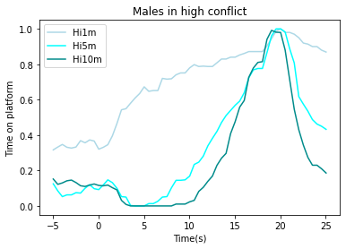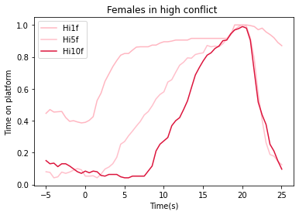

**D**

**C**

**Figure 3: Males vs. females in conflict training and conflict testing.** First, middle, and last day of high conflict training for male mice **3A**. First, middle, and last day of high conflict training for female mice **3B**. Females and males avoidance compared through training days **3C**. Male and female avoidance compared through conflict testing **3D**.

**References:**

1. Bravo-Rivera, C., et al. “Neural Structures Mediating Expression and Extinction of Platform-Mediated Avoidance.” *Journal of Neuroscience*, vol. 34, no. 29, July 2014, pp. 9736–42. *DOI.org (Crossref)*, <https://doi.org/10.1523/JNEUROSCI.0191-14.2014>.
2. Bravo-Rivera, Hector, et al. “Characterizing Different Strategies for Resolving Approach-Avoidance Conflict.” *Frontiers in Neuroscience*, vol. 15, Feb. 2021, p. 608922. *DOI.org (Crossref)*, <https://doi.org/10.3389/fnins.2021.608922>.
3. Diehl, Maria M., et al. “Active Avoidance Requires Inhibitory Signaling in the Rodent Prelimbic Prefrontal Cortex.” *ELife*, vol. 7, May 2018, p. e34657. *DOI.org (Crossref)*, <https://doi.org/10.7554/eLife.34657>.
4. Data source; Provided by the Principal Investigator of the Bravo Lab at the University of Puerto Rico, Medical Science Campus.